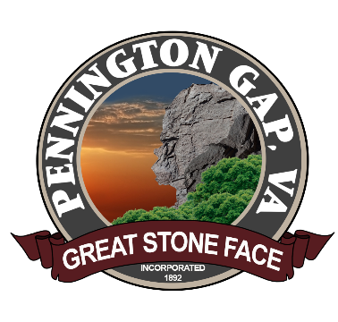

In today's society, the use of social media has become an integral part of our daily lives. It serves as a platform for social interaction, accessing news and information, and making decisions. Social media is a valuable communication tool that allows us to connect with others locally and worldwide, as well as share, create, and spread information.
NOTE: Use of the Official Facebook Pages of Lee Theatre and Town of Pennington

The purpose of the Facebook pages of Lee Theatre and the Town of Pennington is to provide a moderated, online discussion board format for presenting matters of public interest to Pennington Gap residents, businesses, and visitors of all ages and backgrounds. We encourage you to submit your questions, comments, and concerns about these matters either through email or by commenting on specific posts.

However, it's important to note that these Facebook pages are not public forums but moderated discussion boards that are reviewed during normal business hours.

To ensure the purpose of these Facebook pages is fulfilled, The Town of Pennington will take appropriate actions, including blocking access to profiles and removing comments, in the following situations:

1. Off-topic: Comments that are clearly unrelated to the subject matter of the post or the purpose of the page will be considered off-topic and may be removed.
2. Spam: Posts or comments from fictitious pages or profiles that are intended for promotional or disruptive purposes will be considered spam and may be removed.
3. Advocacy for illegal activity: Any posts or comments advocating for or promoting illegal activities will be removed.
4. Vulgar language: Comments that contain vulgar or offensive language will not be tolerated and may be removed.
5. Personal attacks: Comments that include personal attacks, insults, or derogatory remarks towards individuals or groups will be removed.
6. Inflammatory political, religious, or racial attacks: Comments that incite or perpetuate inflammatory discussions related to political ideologies, religious beliefs, or racial/ethnic backgrounds will be considered inflammatory and may be removed.

Please note that the comments posted during discussions on these Facebook pages do not reflect the official opinions and positions of The Town of Pennington, its representatives, and employees.

Thank you for your cooperation and for following the Lee Theatre and Town of Pennington on Facebook.

